ACTIVITY #01

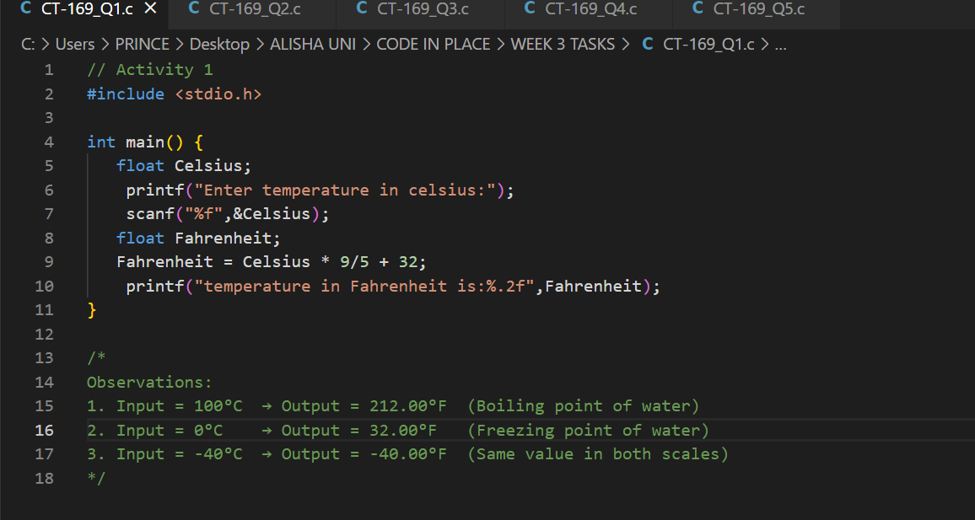

ACTIVITY #02

ACTIVITY #03

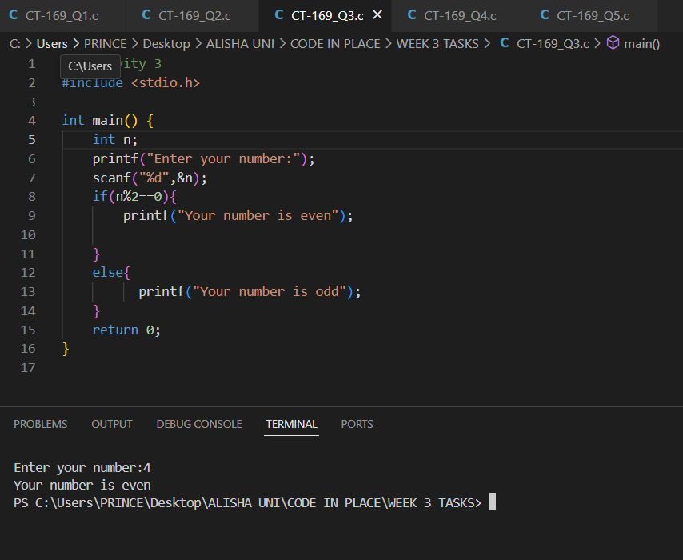

ACTIVITY #04

HANDS ON ACTIVITY



